**Remote (Distributed) testing:**

Why?

1)to simulate user load which jmeter client machine is not able to handle due to infrastructure or hardware limitations

2)to generate user load from different geographies to get realistic result parameters -response time

**Architecture:**

Works on **master slave** mechanism

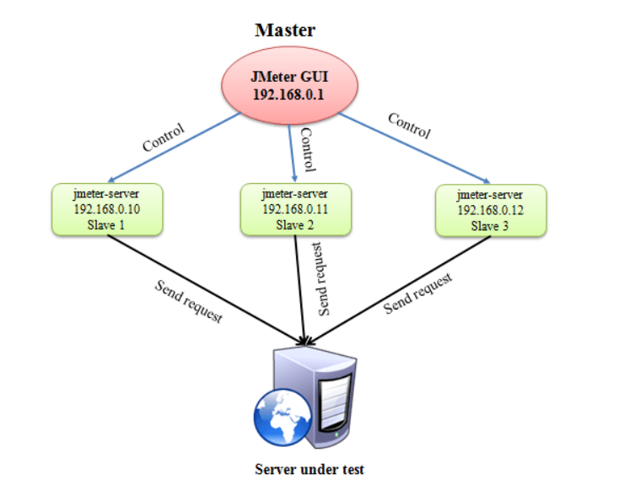

**Helpful tips:**

1)Master and slave machines must have jmeter installed on them (similar version)

2) Master and slave machines must have java installed on them (similar version)

3) Master and slave machines must connect to each other (same subnet)

4)no need to copy jmeter script(jmx) to slave systems

5)If you want to have 100 users and using 2 slaves. Give no as 50.

**Configurations:**

**Step 1:** Provide the ip address of remote host in the jmeter property file and setup master

**Step 2**: Run “create-rmi-keystore” and provide the random answers to the questions then rmi_keystore.jks file will be created

First name & last name: rmi

Password: changeit

Paste this file to remote hosts jmeter/bin folder

**Step 3:** run jmeter-server file on slave(remote) system

**Step 4:** Run and validate

GUI and command line ( jmeter -n -t "D:\Jmeter_demo\Remote_distributed.jmx" -l "C:\Users\broy\Desktop\GuiNon.csv" -R 192.168.18.21 )